**Introduction to Computer Architecture and Organization**

**LAB # 01**



**Fall 2022**

**CSE304L Computer Organization & Architecture**

Submitted by: **Ashfaq Ahmad**

Registration No: **19PWCSE1795**

Class Section: **B**

“On my honor, as student of University of Engineering and Technology, I have neither given nor received unauthorized assistance on this academic work.”

Student Signature: ______________

Submitted to:

**Prof: Ammad khalil**

November 8, 2021

**Department of Computer Systems Engineering**

**University of Engineering and Technology, Peshawar**

**Computer Architecture and Organization**

* What is Computer Architecture and Organization?
* Computer Organization and Architecture is the study of **internal working**, **structure** and **implementation** of a computer system.
* It is the combination of two words.

Let’s discuss it below,

**Computer Architecture:**

* What the system does.
* Computer architecture is a set of rules and methods that describe the functionality, organization, and implementation of computer systems.
* It acts as the interface between hardware and software.
* Computer Architecture helps us to understand the **functionalities of a system.** (It deals with the functional behavior of a system).
* Computer Architecture deals with high-level design issues.
* A programmer can view architecture in terms of instructions, addressing modes and registers.
* Architecture involves Logic (Instruction sets, Addressing modes, Data types, Cache optimization)

Note: In this course we will study MIPS Architecture. MIPS stand for Microprocessor without Interlocked Pipelined Stages.

**MIPS Architecture Overview:**

The MIPS architecture is a Reduced Instruction Set Computer (RISC). This means that there are a smaller number of instructions that use a uniform instruction encoding format. Each instruction/operation does one thing (memory access, computation, conditional, etc.). The idea is to make the lesser number of instructions execute faster. In general RISC architectures, and specifically the MIPS architecture, are designed for high-speed implementations.

**Computer Organization:**

* How the system do.
* It deals with the structural behavior of a system.
* It deals with the connection of the components in a system.
* Computer Organization tells us how exactly all the units in the system are arranged and interconnected.
* An organization is done on the basis of architecture.
* Computer Organization deals with low-level design issues.
* The significant components of Computer organization are ALU, CPU, memory and memory organization.
* Organization involves Physical Components (Circuit design, Adders, Signals, and Peripherals).

**Note:** for designing a system first architecture is required than organization.

**Two Types OF Architecture:**

1. RISC
2. CISC
3. **RISC:**

* The term RISC stands for ‘’Reduced Instruction Set Computer’’.
* It is a CPU design plan based on simple orders and acts fast.
* This is a small or reduced set of instructions.
* Here, every instruction is expected to attain very small jobs.
* In this machine, the instruction sets are modest and simple, which help in comprising more complex commands.
* Each instruction is about a similar length; these are wound together to get compound tasks done in a single operation.
* Most commands are completed in one machine cycle.
* This pipelining is a crucial technique used to speed up RISC machines.

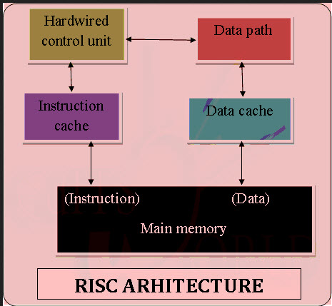

1. **CISC Architecture**

* The term CISC stands for ‘’Complex Instruction Set Computer’’.
* It is a CPU design plan based on single commands, which are skilled in executing multi-step operations.
* CISC computers have small programs.
* It has a huge number of compound instructions, which take a long time to perform.
* Here, a single set of instructions is protected in several steps; each instruction set has an additional than 300 separate instructions.
* Maximum instructions are finished in two to ten machine cycles.
* 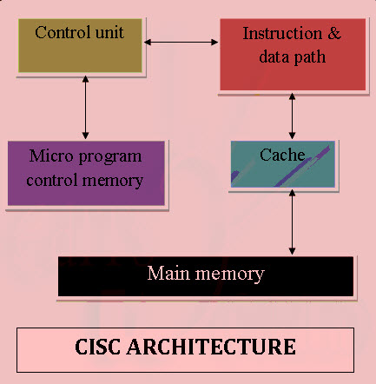In CISC, instruction pipelining is not easily implemented.

Comparison:

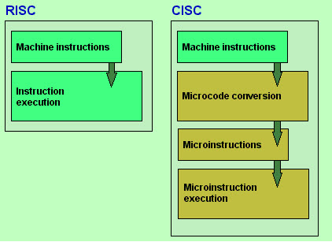

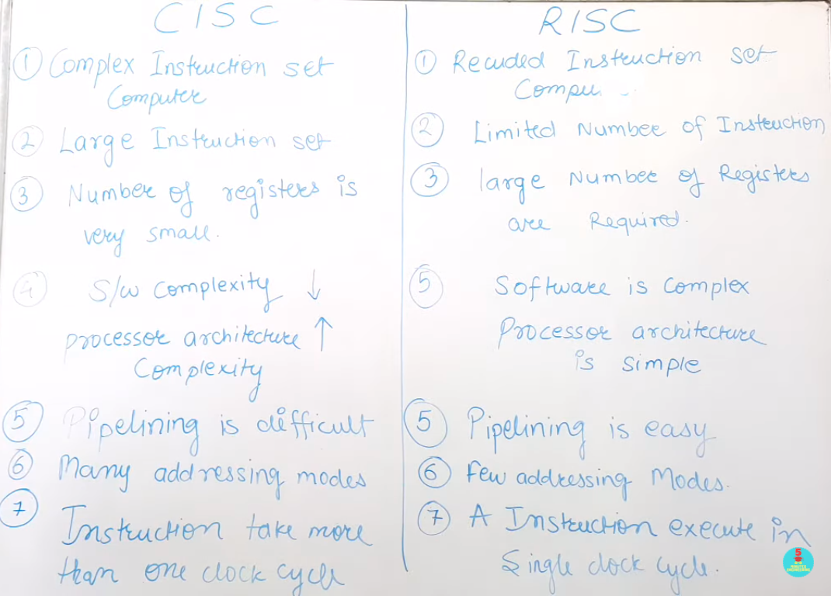

**QTSPIM Software:**

* It is the latest version of SPIM.
* SPIM is a MIPS processor simulator, designed to run assembly language code for this architecture
* QtSpim is software that will help you to simulate the execution of MIPS assembly programs.
* It does a context and syntax check while loading an assembly program. In addition, it adds in necessary overhead instructions as needed, and updates register and memory content as each instruction is executed.

**QtSpim workspace:**

